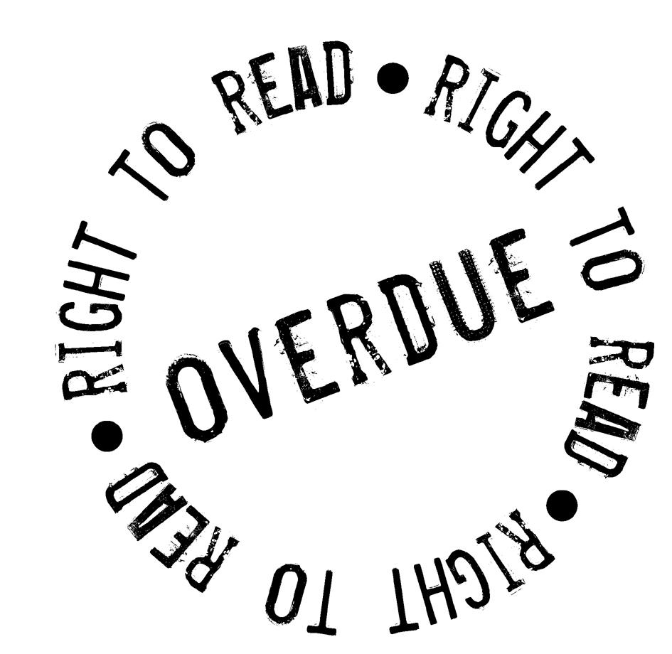Declaration on the Right to Read

Background:
- At least three hundred million people around the world with sight problems and dyslexia cannot read standard print. India may be home to at least 70 million of these persons.
- Globally, a massive 96 percent of books are never made available in formats that persons with print disability can enjoy and in India almost 99% books are unavailable in accessible formats.
- Every day millions of adults and children are denied vital information for education, work, daily life as well as being denied the joy of reading a world of books.
- The Indian Copyright Act 1957 does not permit conversion and distribution of books in accessible formats to persons with print disabilities

We believe that:
- Everyone, regardless of disability, has the right to read. Being blind, partially sighted, having dyslexia or another print-reading disability should not be a barrier to reading.

Solutions:
- The Government of India must immediately modify the Indian Copyright Act 1957 to permit conversion and distribution of books in accessible formats to persons with print disabilities.
- India should support the Treaty for the Blind proposed at the World Intellectual Property Organisation by the World Blind Union (WBU), which is aimed at harmonisation of copyright laws at an international level.

We invite publishers and authors to join us in opening up the world of reading to persons with print impairments by making books available in accessible formats like Braille, large print, audio and electronic formats.
Join us in our campaign to convince the Government that urgent action is needed. If you believe that everyone has the right to read, help us unlock a world of books by adding your name to the global declaration. We need your support.

Sign the Declaration
If you wish to support our campaign, add your details below and email the declaration to support@righttoread.in

Your name | Address and/or email | Tick*

*The personal details you provide will be used only for the Right to Read Campaign. Please tick alongside your email address if you are happy to receive email and other electronic forms of communication regarding the Right to Read Campaign.

You can also print this document, collect signatures from your friends and family, and send a scanned copy of the same to support@righttoread.in or post it to The Right to Read Campaign, Centre for Internet and Society, No. D2, 3rd Floor, Sheriff Chambers, 14, Cunningham Road, Bangalore - 560052

Thank you for your support

Campaign  Managers | Daisy Forum of India (www.daisyindia.org)  Bookbole.com (www.bookbole.com)  Centre for Internet & Society (www.cis-india.org)
This initiative is a part of the official global Right to Read campaign launched by the World Blind Union.

