

No. D2, 3rd Floor, 14, Cunningham Road, Bangalore - 560 052, India Ph: +91 80 4092 6283 Web: www.cis-india.org

Dear Sir or Madam,

The government had done a commendable job of releasing a progressive and forward-looking policy on the usage of open standards in e-Governance. Globally the European Union's Electronic Interoperability Framework (EIF) guidelines (version 2 of which is currently in the draft stage) is deemed to be the gold standard as far as open standard policy is concerned. The draft National Policy on Open Standards meets all of the EIF's four open standard requirements. However, there is still some room for improvement as discussed below:

While the document talks of the standard being royalty free (4.1 and 5.1.1) and without any patent-related encumbrance (4.1), it limits those requirements "for the life time of the standard" (5.1.1), whichseems a bit ambiguous and is not defined in the appendix either. It would be preferable to make it royalty-free for the lifetime of the patents (if any) as open archival material shouldn't one day (after the end of "life time of the standard", and before the expiry of the patents) suddenly be forced to become paid archives. It would be desirable to make declarations of patent non-enforcement irrevocable (as the EU EIF does), by incorporating a wording such as: "irrevocably
available on a royalty-free basis, without any patent-related encumbrance".

There should also be a separate provision in the "policy statement on open standards adoption in e-Governance" section of the document making explicit that there can be no restraint on use or implementation of the standard (as has been stated in the "guiding principles" section).

Perhaps when talking of specification documents (5.1.5) the words "any restrictions" could be amended to include a few examples of what the term "any restrictions" would include. The document could make explicit that it must be permissible for all to copy, distribute and use the specifications freely, without any cost or legal barriers.

Sometime private companies can interfere with the standardisation process, the document could perhaps be more explicit regarding remedial measures that could be undertaken in the event – for example use of competition law, as in the case of the EU EIF which states: "Practices distorting the definition and evolution of open standards must be addressed immediately to protect the integrity of the standardisation process."

As it stands, the draft document addresses many notions of openness (freely accessible, at zero cost, non-discriminatory, extensible, and without any legal hindrances, thus preventing vendor lock-in), and there is much to applaud in it. It has a clear implementation mechanism, with a laudable aim of establishing a monitoring agency and an Open Source Solutions Laboratory. It is applicable not only to future e-Governance initiatives, but to existing ones as well. Furthermore, it also has an in-built review mechanism, which is crucial given the rate of change of technologies and consequently of the requirements of the government. Thus, the draft policy document very clearly encourages competition and innovation in the software industry and promotes the Free and Open Source Software (FOSS) movement and industry. As researchers from UNU MERIT have pointed out, even a nominal fee for usage of a standard can lead to exclusion of FOSS implementations, leading to less competition in the software industry. Thus, all in all this draft document represents a commendable effort by the Indian government towards a sustainable and robust e-Governance structure based on open standards. However, a few small amendments as suggested in this letter would make it an even greater guarantor of openness.

Yours sincerely,

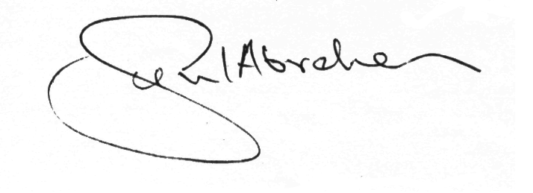

Sunil Abraham,
Director – Policy
Centre for Internet and Society. Bangalore

List of Cosignatories
- Richard Stallman, Founder, Free Software Foundation, USA.
- Shahid Akthar, Founder, International Open Source Network, Canada.
- Denis Jaromil Rojo, Developer, Dyne.org, Netherlands.
- Raj Mathur, Consultant, Kandalaya.org, New Delhi

